**Question 1:**

a)

Set Cover (SC) as a decision problem, is defined as below:

Given the following: a universe U of n elements, a collection of subsets of U (for example S = {S1, S2,...Sm}) where every subset Si has an associated cost.

Find a minimum cost subcollection of S that covers all elements of U.

* The problem describes a set of sets whose union will have all members of the union of all sets. The goal of the problem is to find the minimum size set.

In order for SC to be NP-Complete via Turing Reduction the problem must be proven to be both NP, and NP-hard, therefore making it NP-Complete.

b)

An independent set is a set of vertices in a graph in which no two vertices are adjacent.

In other words,

A set of vertices S such that for every two vertices in the set there is no edge which is connecting the 2. Also, each edge in the graph being used has at most one endpoint in S.

A set is independent if it is a clique in the graph’s complement.

c)

If a Turing reduction from A to B exists, then each algorithm for B is allowed to be used to produce an algorithm for A. Therefore, the first friend is correct.

To prove that a given decision problem X is NP-Complete, then one must Turing reduce a known NP-Complete problem to X.

d)

The certificate returned by the oracle is essentially the output of the corresponding optimization problem.

e)

The 3 factors to show that a given problem is NP are:

1. Show that it can be a decision.
2. It must be able to be passed to the oracle
3. The certificate can be verified in polynomial time

Therefore, for a problem to be NP, it must have those 3 factors

For File Bin Packing to be in NP:

* It must be a decision problem
  + It is a decision problem since it does not ask for an optimal solution
* Then it must be asked to the oracle
  + It can be since a yes or no answer would be viable
* The certificate from the oracle must be verified in polynomial time

**Question 2:**

a)

The Travelling Salesman problem (TSP) cannot be approximated unless P= NP because if one can give a good approximation solution to TSP in polynomial time, then we can exactly solve the NP-Complete Hamiltonian cycle problem in polynomial time, which is not possible unless P= NP.

b)

We present a polynomial time approximation scheme for Euclidean TSP in fixed dimensions. For every fixed c > 1 and given any nodes in ℜ2, a randomized version scheme finds a (1 +1/c)-approximation to the optimum traveling salesman tour in O(n(log n)O)) time.

c)

d)

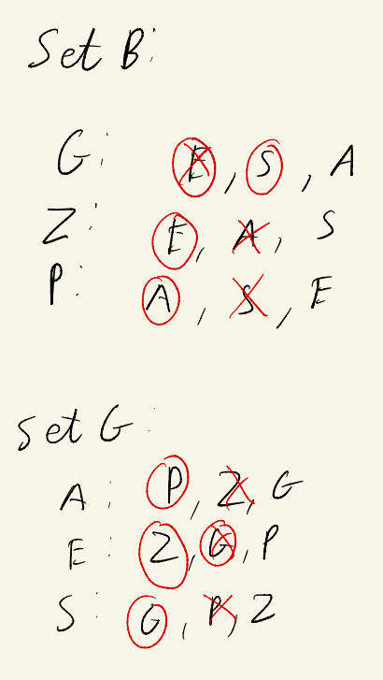

Stable Matchings:

Ganni -> Susan

Zeppi -> Eileen

Pawlu -> Anna

**Question 3**

a)

Suppose that T = katakana

T$ = katakana$ (Sentinel character is added just in case there are suffixes that are prefixes or other suffixes)

The suffixes are:

* katakana$
* atakana$
* takana$
* akana$
* kana$
* ana$
* na$
* a$
* $

The Suffix Trie:

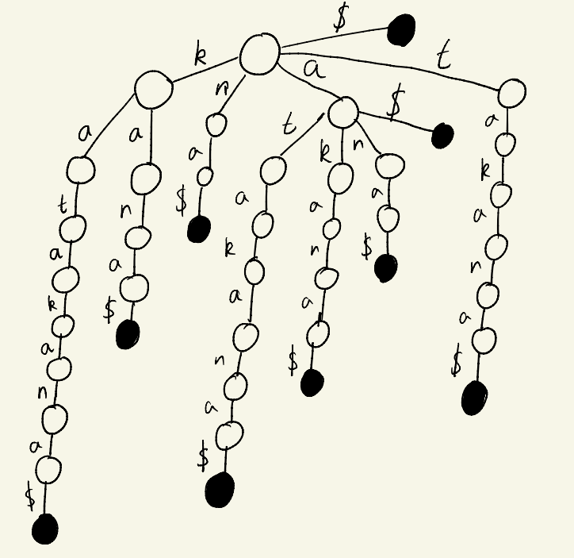

b)

i). Yes, P1 does have a polynomial time algorithm because since P1 ∝ P2, and P2 has a polynomial time algorithm, then so does P1.

ii). Yes, P3 also has a polynomial time algorithm. This is because P2 ∝ P3, and since P2 has a polynomial time algorithm, then so does P3.

c)

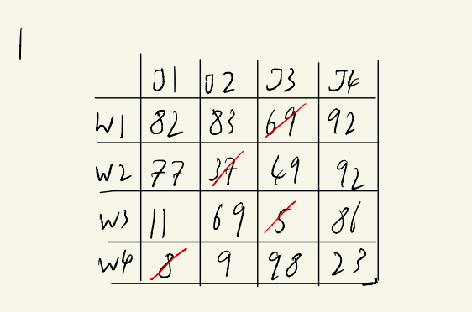

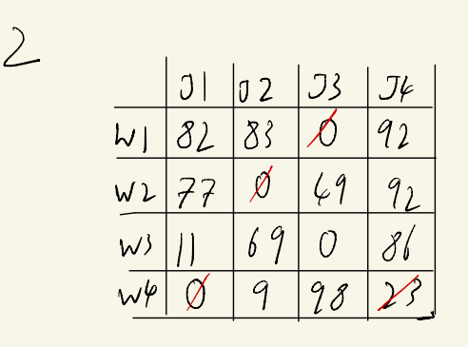

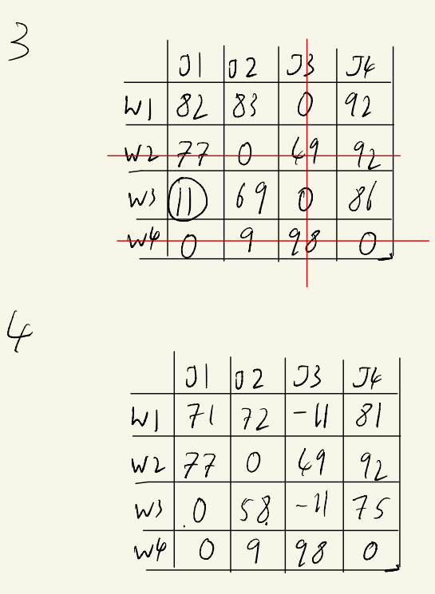

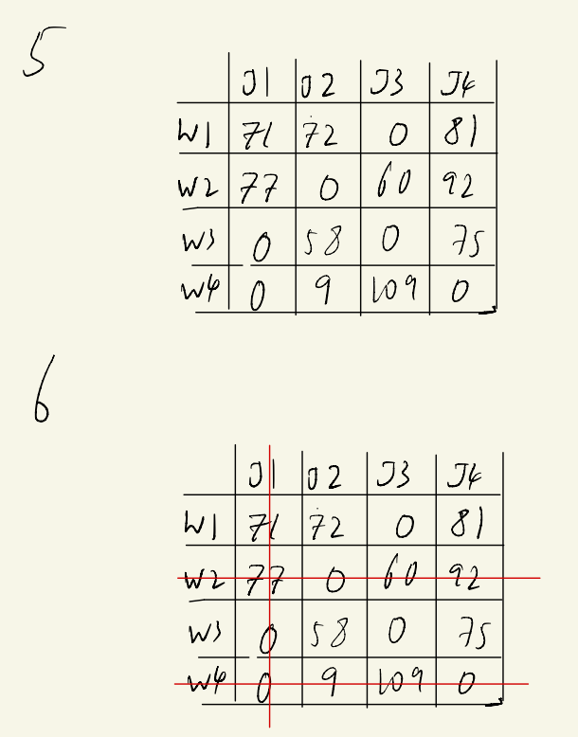

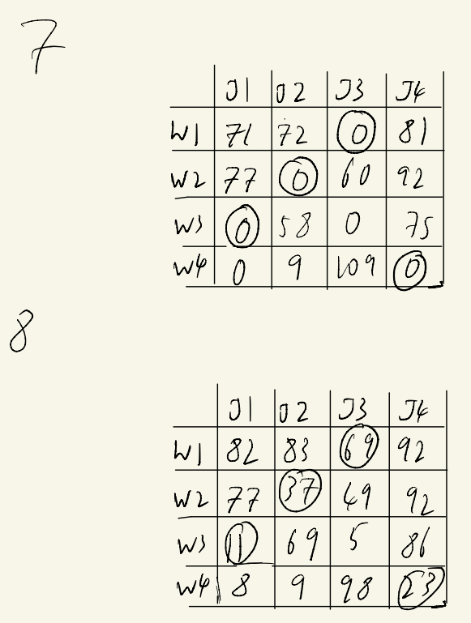

Minimum Cost Assignment = 69 + 37 + 11 + 23

d)